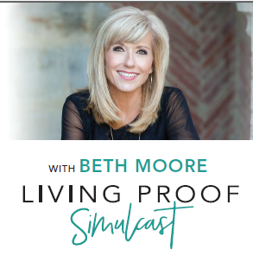
First Southern Baptist Church
1101 South Albany Street
Yuma, Colorado 80759
(970)848-5656
Saturday, September 29, 2018
Doors open at 8:00 – Event begins at 9:00 – LifeWay Store on site
Light breakfast, lunch and simulcast materials provided

Registration

Name: _______________________________________________________________________________

Address: _____________________________________________________________________________

City: ______________________ State: ______________________ Zip Code: ____________________

Phone: _______________________________________________________________________________

Email Address: ________________________________________________________________________

Do you have a church home? YES or NO (circle one)
If so, where do you attend? ______________________________________________________________

Would you like updates for FSBC Women’s Ministry events? YES or NO

______ X $15 per ticket (before Sept. 1, 2018; $20 after) $ ________________________
Total Amount Enclosed

Please make checks payable to First Southern Baptist Church of Yuma. If you have any questions or need additional information, please contact the church at 970.848.5656 or Cindy Mulder at 970.630.6244.

